SPREADSHEET WORDSEARCH

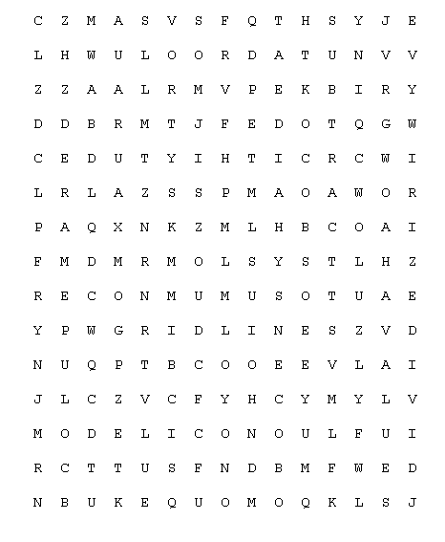

ACTIVE | ADD | AUTOSUM
CHART | COLUMN | DIVIDE
FORMULA | GRIDLINES | LABEL
MODEL | MULTIPLY | ROW
SUBTRACT | VALUE | WORKSHEET

